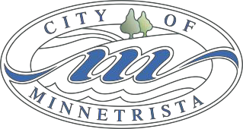

CITY COUNCIL
WORK SESSION MEETING AGENDA
August 21, 2023
5:30 – 6:30pm

- Call to Order
- 2024 Budget Discussion
- 10-Year Street CIP Review
- Employee Wellness Policy
- St. Bonifacius Watermain Interconnect Update
- Adjourn

